Article

Planning and Scheduling of a Construction Renovation Project using BIM-based Multi-Objective Genetic Algorithm

Pornpote Nusen 1, Wanarut Boonyung 2, Sunita Nusen 3, Kriengsak Panuwatwanich 4, Paskorn Champrasert 5 and Manop Kaewmoracharoen 1,5,*

1 Department of Civil Engineering, Faculty of Engineering, Chiang Mai University, Chiang Mai, 50200, Thailand; pornpote_n@cmu.ac.th

2 Department of Computer Engineering, Faculty of Engineering, Chiang Mai University, Chiang Mai, 50200, Thailand; wanarut.b@gmail.com

3 Department of Civil and Environmental Engineering, Faculty of Engineering,   
Rajamangala University of Technology Lanna, Chiang Mai, 50300, Thailand; sunita@rmutl.ac.th

4 School of Civil Engineering and Technology, Sirindhorn International Institute of Technology,   
Thammasat University, Pathum Thani, 12120 Thailand; [kriengsak@siit.tu.ac.th](mailto:kriengsak@siit.tu.ac.th)

5 Optimization Theory and Applications for Engineering SYStems Research Group (OASYS), Chiang Mai University, Chiang Mai, 50200, Thailand; [paskorn@eng.cmu.ac.th](mailto:paskorn@eng.cmu.ac.th) (P.C.), [manop@eng.cmu.ac.th](mailto:manop@eng.cmu.ac.th) (M.K.)

**\*** Correspondence: manop@eng.cmu.ac.th; Tel.: +66-53-944-157

Received: date; Accepted: date; Published: date

**Abstract:** Construction renovation is known as a complicated type of construction project and prone-to error comparing to a new construction. Combination of several complexity from staying open during renovation, extra-large building renovation, and strictly-regulation governmental building renovation are causing loss of team communication and construction performance. Given the current availability of robust hardware and software, building information modeling (BIM) and optimization tools have become an essential tool to improve construction planning, schedules, and resource management. This study explored opportunities to develop multi-objective genetic algorithm (MOGA) on existing BIM. The data was retrieved from a renovation project during 2018-2020. Project direct costs, indirect costs, actual schedule, and resource usages were tracked and retrieved creating a BIM-based MOGA model. The results consist of many solutions. All solutions are optimal. It up to users that they will pick which solution to use. Furthermore, this proposed method consumes the cycle of process less than the linear programming solver. It can be used as an efficient tool for construction planning and scheduling using a combination of existing BIM along with MOGA into professional practice. The construction process will be beneficial from useful information for better decision-making depending on their strategies based on the pareto front data provided.

**Keywords:** renovation; planning; scheduling; building information modeling; multi-objective genetic algorithm; resource utilization

1. Introduction

Nowadays construction management facing several uncontrollable and controllable challenges. Characteristics of construction industry always have external factors uncontrollable such as unpredictable weather, local resource scarcity, and various strict regulations. Traditional construction management deals with controllable factors such as inconsistency design, lack of constructability, inaccuracy document, and redundant work processes. Building information modeling (BIM) has been widely used for a decade to improve efficiency in construction project especially for construction planning and document. It provides data and visualization to project managers to make a better decision for improved quality and faster processes [1]. It also helps solving design collisions as a conflict management between interdisciplinary engineers for complex projects such as renovation or extra-large building [2]. Construction complexity is one of construction issues which has direct effect in project communication and performance [3]. Construction renovation projects are complex by its nature because of physical constraints such as obsolete conditions, limited access, and unknown conditions underneath. Some renovation projects get more complex if there is a requirement of business operation during construction. Contractors need to deal with surplus limitation such as proper noise and odors. An extra-large building construction is another project type of complex construction. It is required multidisciplinary from different engineering firms. Additional laws and regulations are also applied. Project times and resources are greater than typical construction project which is always divided into a multi-phase construction.

A number of practitioners adopted BIM technology as a tool to improve efficiency in construction management. However, an artificial intelligence optimization approach is suggested to make it the most effectiveness. So there is a research opportunity to accommodate complexities with BIM-based optimization combining to an existing traditional construction approach.

1.1. Building Information Modeling

Building information modelling (BIM) was introduced in early 2000s as an information model of building elements. It is widely used in construction industry since then because of better project information flow. It is used for improvement of planning and design, clash detection, visualization, cost planning, and data management. It is always implemented along whole building life cycle from pre-construction, construction, post construction, and operation phases. A BIM model composes of two combining parts: (1) physical properties in three dimension such as material, density, weight, or location and (2) embedded information such as a construction specification or a repair manual. Several researchers and practitioners use BIM for several aspects. It is used to improve communications during the project stakeholder over traditional non-BIM approach [4]. It improved information sync of building coordination in three-dimensional space. This is tremendous improvement comparing to traditional construction drawings. This is sought to be very useful for complex projects like extra-large buildings that are required synchronize between multi-disciplinary people as well as multi-source documents [5]. An integration of BIM-based quality management model is also suggested [6].

BIM has been used for existing buildings in either renovation project or improvement of existing facilities. Facility management [7] and sustainability improvement for existing buildings are BIM major benefits [8]. It also significantly improves construction processes working on existing buildings; however, several challenges are addressed including difficulty of stakeholder involvement and lack of automated capture data [9]. To overcome this challenge, surveying with laser scanning and total station technique is suggested to capture existing buildings to BIM [10]. This technique is also famous for collecting historical buildings information because of touchless surveying with high accuracy [11]. It can be seen that using BIM as a tool for a renovation complex project is viable to create project more successful.

1.2. Construction Planning and Scheduling Optimization

Construction planning and scheduling are the most important activities during pre-construction phase. If it well planned and optimized, it can lead a project to success. Several researchers adopted optimization techniques to solve construction planning and scheduling problems. Linear programming is one of the famous techniques in the past for solving this issue. Multi-objective linear programming is suggested to optimize resource-constrained problem among construction costs, project duration, resource idle time, and delivery project time [12]. A particle swarm optimization is also suggested for a construction scheduling problem. It is possible to solve resource constrained issue with two representations either priority-based or permutation-based representation [13]. An ant colony optimization is another approach for resource-constrained project which focused on minimize project duration while varying activity sequences [14]. Genetic algorithms (GA) have been used in several construction scheduling research such as resource allocation and leveling optimization [15], concrete precast production optimization [16], and nonproductive resource determination [17].

In real construction projects, there always are multiple objectives which optimization data becomes a set of solutions for project managers to make a decision. Multi-objective genetic algorithms (MOGA) was first introduced by Murata in 1995 for providing pareto optimization for decision maker instead of constant weights [18]. It has been discussed for several construction optimization research. MOGA is used for construction time-cost trade off optimization [19]. It is also suggested for using as a tool for construction stie layout optimization. It defines optimal time and cost with variables of crane locations and crews by minimizing crane stopping time [20]. It is able to increase safety and security by optimization of security costs on different project layouts [21]. Even construction quality is used as an objective function for MOGA along construction project time and cost with the result showing their weights and pareto solutions [22].

Combination of BIM and optimization techniques has been used to improve information flow and visualization. BIM-based genetic algorithm is suggested by retrieving information directly from BIM models as an input for GA [23]. Then another approach providing fuzzy set of data input for GA creating BIM-based scheduling optimization [24]. BIM becomes a significant tool for either data input or visualization output of optimization techniques such as BIM-based construction assembly line optimization [25] or BIM-based for building best energy performance design [26].

In this paper the authors integrate the ideas from previous research to develop a BIM-based MOGA. A case study of a renovation of extra-large building project was used to validate proposed BIM-based MOGA. With a renovation project, a construction planning and scheduling get complicated for several issues including limited work areas, hidden conditions, or obscure information.

2. Materials and Methods

2.1. Project Background

A renovation project of Chiang Mai University Main Library, with the size of 15,768 square meters built in 1964, was used in this research. The exterior and interior of the building displayed in figure 1. The renovation was approved by the university in 2015 and started in 2018 with the budget of 86,000,000 baht (approx. 2,350,000 Euro). The project challenges were (1) requirement of operation as regular time with partial closing, (2) extra-large building regulation, defined in Thailand Ministerial Regulations ACT 33 B.E. 2535 (announced in 1992), and (3) complicated governmental-university regulations.

The project started on 17th October 2018 with 720 days construction duration. The purposed schedule divided into four phases: (1) the 4th floor renovation from day 1-180, (2) the 3rd floor renovation from days 181-360, (3) the 2nd floor renovation from days 361-540, and (4) the 1st floor renovation and landscape from days 541-720. The project was finally finished on 2nd November 2020 as extended period of 36 days. The project scopes are to improve current look and feel of the building, update MEP (mechanical, electrical, plumbing) and ICT systems to up-to-date standards, and to revamp landscape and surrounding area with a new concrete patio.

|  |  |
| --- | --- |
| (**a**) | (**b**) |

**Figure 1.** Project site of Chiang Mai University Library prior renovation: (**a**) Exterior view from the west side; (**b**) Interior view on the first floor.

2.1.1. Construction Scheduling

Prior the project started, the project schedule initially set according to the project contract. Information was extracted from the contract which are a project delivery system, bill of quantities (BOQ), resources, phasing, and payment. Then, during the construction, actual schedule, resource usages were retrieved on-site from daily site progress reports. The first phase focused on demolition of existing walls and removing existing ceilings and floors. Then the project closed each floor starting from the 4th floor allowing 1st, 2nd, and 3rd floors operates as usual.

The original scheduling data was retrieved from the main contractor as a Microsoft Project and Microsoft Excel files. On-site data were collected including the numbers of workers, crew sizes, actual durations, and project progress for two years. Then all data from different sources were used for creating BIM model.

2.1.2. BIM Model Development

The original design of the building was illustrated in figure 2 as an as-built drawing. However, over 50 years there had been several minor renovations and modifications which were not recorded in any hardcopy format. A BIM model was developed based on as-is condition from the as-built drawing, terrestrial laser scanning survey data, and on-site survey data.

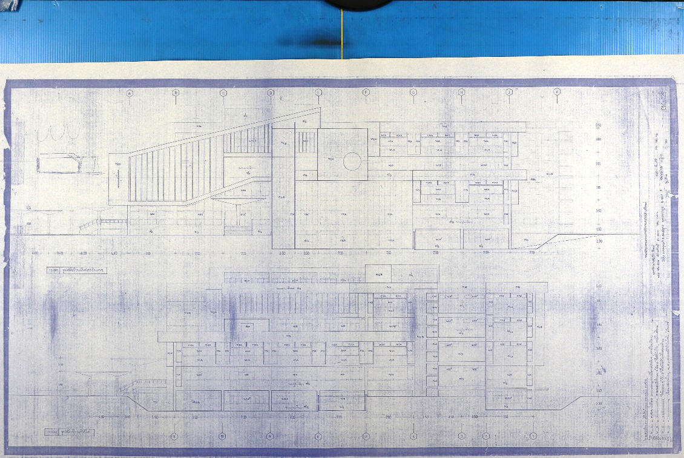

**Figure 2.** Chiang Mai University Library as-built drawing blueprint from 1964.

The renovation project BIM model was initially created based on the as-built drawing; however, several details are missing neither from faded blueprint nor non-recorded renovation activities. Moreover, information from a traditional two-dimension blueprint was obscure and prone to error due to several unconnected figures, tables, and remarks. Then a traditional on-site survey along with terrestrial laser scanner were done to collect as-is condition of the building and surrounding area. Three-dimensional point cloud data were retrieved from the survey. Then the point cloud data was overlayed on top of the existing as-built drawings to complete the building information. When data from different sources were combined, discrepancy data was appeared as illustrated in figure 3, an example of an opening position error comparing between the as-built drawings and as-is condition. This approach is a typical initial BIM approach for gathering data in renovation projects in present day.

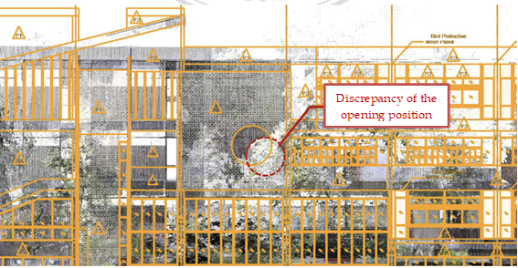

**Figure 3.** Point cloud dataset from terrestrial laser scanner on the existing building and its surrounding of Chiang Mai University Library.

Then BIM model was created for visualization (3D BIM) and project schedule (4D BIM). The figure 4 displayed the 3D BIM model for visualization.. It displayed the final appearance when renovation completed. This used for communication among project stakeholders. The scheduling model displayed as a 4D BIM from a combination of the 3D BIM model and a project Gantt chart as illustrated in the figure 5. Appearance of building elements changed and highlighted according to a specific date. This allowed the project stakeholders discussing and monitoring of the current project schedule in efficient manner. Moreover 4D BIM renovation was helpful since several demolition tasks did not display in the model but required significant project resources. This allowed the project stakeholders to plan and schedule for non-element construction task much easier than traditional approach. In this 4D BIM model, a demolition model and a new renovation model are overlapped for planning and scheduling as different project phases.

During the construction, schedule and resources information was collected on site and put back to the model for controlling and monitoring. Finally total cost data was also retrieved and then used for project management throughout the project life cycle.

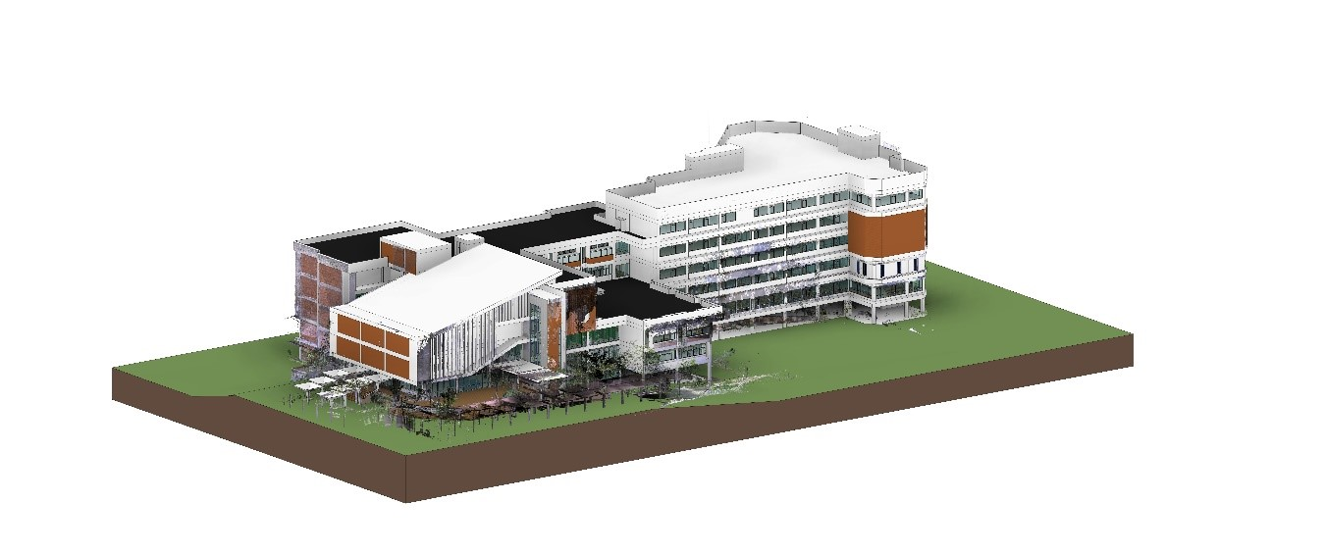

**Figure 4.** Rendered BIM model of Chiang Mai University Library for visualization.

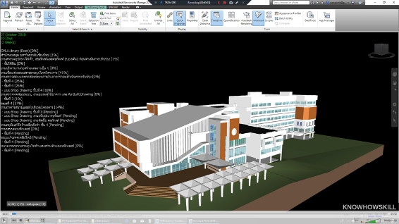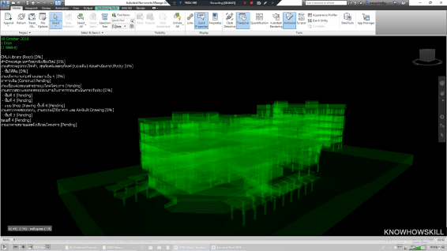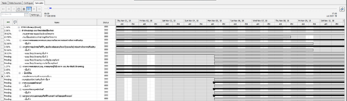

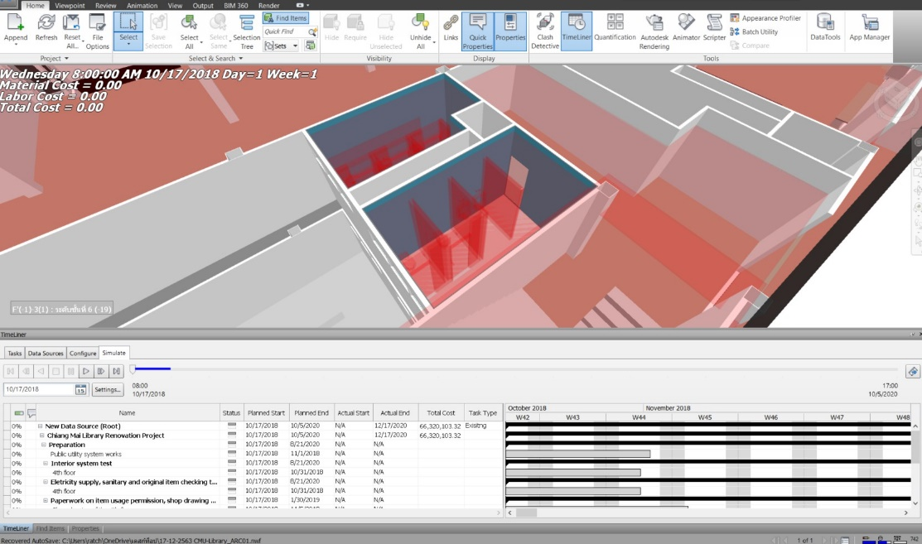

**Figure 5.** Scheduling model as 4D BIM displaying the 3D models linking with Gantt chart

2.2. Optimization Definitions

Optimization problem of the multi-objective optimization was defined with goal to minimize total cost, minimize construction time, and minimize variance of number of workers per day.

|  |  |
| --- | --- |
| *Total cost = DC + IC + LPF* | (1) |

Where DC is direct cost; IC is indirect cost; DC+IC is contract price ; and LPF is late penalty fee.

|  |  |
| --- | --- |
| *Direct cost = MC + LC* | (2) |

Where MC is material cost; and LC is labor cost.

|  |  |
| --- | --- |
| *Indirect cost = Indirect factors × Ta* | (3) |

Where Ta is actual construction time

|  |  |
| --- | --- |
| *Late penalty fee(LPF) = Daily penalty fee × (Ta – Tc)* | (4) |

Where Ta is actual construction time and Tcis contract construction time

|  |  |
| --- | --- |
| Construction time = Max *FTi* | (5) |

Where *FTi* is finish time of activity i

|  |  |
| --- | --- |
| $${Number of workers per day }_{t}=\sum_{i=1}^{n}{\left(\frac{Q_{i}}{D_{i} x {PDR}_{i}}\right)}$$ | (6) |

Where n is total number of activities in day t; Qi is Quantity of activity i; Di is Duration of activity i; and PDRi is Productivity rate of the worker for activity i

|  |  |
| --- | --- |
| $$Workers utilization fluctuation=\sum_{t=1}^{T}{{[{Number of workers per day }_{t}]}^{2}}$$ | (7) |

Where T is total number of project working day

2.3. Problem Definitions

To optimize a project cost, a project duration, and resouce usages while maintaining BIM data pipeline are crucial for this research. Typically data in BIM itself is interconnect allowing 3D model and scheduling updated automatically. However, when dealing with a complex solution, BIM requires external optimization tools and need to leave the BIM data pipeline. This causes redundant manually tasks and prone to error. To optimize those objectives and exchange data back and forth via BIM. It was successful usage to satisfy these requirements [27] which still use BIM as embedding informations into a three dimensional representation [23]. Multi-objective genetic algorithm (MOGA) is considered one of popular methods for solving multi-objective problems. It provides optimal pareto front for decision makers instead of static objective weights.

3. BIM-MOGA Model

In addition, to optimise simultaneously the performances referred to different aspects, multi objective optimisation is more appropriate. In this section, the development of BIM-MOGA is described. By retrieving information of a project from the BIM, MOGA process will start solving multi-objective optimization problems using GA. Once the Pareto frontier has been defined, the best solution will then be chosen by the decision makers. the renovation scheduling is gernerated by Microsoft Project. After that, the researcher exported the file to Autodesk Navisworks and exported BIM from Autodesk Revit to Autodesk Navisworks in order to create a 4D BIM for the renovation project. This allows the concerned parties to overview the process, reduces the workloads and conflicts while working at the site. It also helps improve the collaboration between the concerned parties. Each related part is explained in details in the following sections.

The proposed model is a multi-objective optimization for minimizing project duration, cost and resources simultaneously. The method steps to generate an optimized schedule are illustrated in Figure 5. The optimization model is developed and organized into three main modules: 1) Initialization Module: Construction data are calculated i.e., an initial project schedule and the number of total float days; 2) BIM Module; and 3) MOGA Module. These three main modules are described in more detail in the following sections.

*1) Initialization Module*

There are three main calculations for this module.

1. Actual construction time (Ta) calculation

According to construction data from each activity and project calendar constraint, i.e., activity duration (Di), activity sequence and exception date (ei) from baseline schedule. We defined the Precedence network, referred to as the Precedence Diagram Method (PDM) logic. In PDM, there are four precedence relationships constraints: Finish to Start (FS), Start to Start (SS), Finish-Finish (FF) and Start-Finish (SF) with overlapping time (Li).

Precendence Network computation procedure, used a sequential forward and backward calculation through the network to calculate; the early start times(STi) to early finish times (FTi), late start times(LSi) to late finish times(LFi) for each activity. From these values, Total Float time(TFi) and actual construction time(Ta) are determined using eq.8-9. With the term plus one in Eq.8, the results could be combined with BIM model in terms of Gantt Chart.

|  |  |
| --- | --- |
| $$TF_{i}=LF_{i}-{FT}_{i}-D_{i}-ⅇ_{i}+1$$ | (8) |

Where TFi = Total Float of activity i

|  |  |
| --- | --- |
| *Ta = Max ${FT}_{i}$* | (9) |

Where Ta is actual construction time; FTi is finish time of activity i

2) Resource utilization fluctuation (Mx) calculations

The moment *Mx* is calculated by summing the daily moments, as shown in eq.6-7, refered to Number of worker calculation base on the Quantity of activity i (Qi) from BIM Model and productivity rate of the worker for activity i (PDRi)

3) Total Cost(Ct) calculation

Total cost (Ct) is calculated using eq.1, which is referred to as Direct cost (DC), Indirect cost (IC) and Late penalty fee (LPF). DC is calculated using eq.2 that includes material cost and labor cost, material cost is a function of material quantity from BIM model as shown in eq.10 , while labor cost are functions of daily payrate of workers as shown in eq.11. IC is calculaeed using eq.3 and LPF is calculated using eq.4

|  |  |
| --- | --- |
| $$Material cost(MC)=\sum_{i=1}^{N}{[{Material cost unitrate}_{i} x Q_{i} ] }$$ | (10) |
| $$Labor cost(LC)=\sum_{t=1}^{Ta}{[{Number of workers per day }_{t} x {Pay rate }_{t} ] }$$ | (11) |

*2) BIM Module*

Once the construction data are calculated, they are transferred to BIM module. BIM enables the concerned parties to see the 3D visualization of the project in its current stage. The collision check is conducted before the start of the construction so the design imperfections from the collision problems are identified. The schedule planning is correlate with the model under BIM technology. The BIM-based schedule was integrated to the 4D model and used as a visualization tool. The Activity ID generated by the 4D BIM is used to link schedules with 3D objects. To create the actual construction stimulation, actual work start time and end time are put in the model. Resource and cost are also monitoring. “BIM Model” can be used for dynamic management process simulation of project progress. A baseline schedule providing required data from BIM Model is consequently imported to the optimization module.

*3) MOGA Module*

Through MOGA, the project objectives were set and the program defined optimization constraints i.e., initial constraints; Model’s parameters including number of constraints and independent variables and project’s parameters including number of activities, precedents and successors of activities~~,~~ resources availability during project execution (i.e., resource constraints) and Cost data. The project calendar according to contract constraints – time, special agreements was setting up. Next, the program worked through the genetic algorithm optimizer. It, then, proposed candidates and identified ones that were validate. Once the MOGA process was complete, the set of Pareto optimal solutions was obtained. A 4D BIM model renovation simulatuon and a 5D BIM model including cost estimation progress were visualized. Then the decision maker can choose any one of the Pareto optimal solutions. Pareto fronts allow the decision makers to select the optimum solution from a set of solutions based on constraints of their projects.

2D Plan

Planned Schedule

Actual schedule

Budget cost

Actual cost

Construction data

3D Model

4D Model

BIM Model

BIM

BIM Visualization

Define optimization constrains

Genetic algorithm optimizer

Candidates

Validate candidates

Pareto front

MOGA

**Figure 5.** The flow diagram of optimization procedure.

3.1. Optimization Model

This paper’s problem consists of three objectives. All objectives are not on the same scale and unit. we can use the weighted-sum method [28]. But we do not know which values make sense. Hence, we use the nondominated sorting genetic algorithm 2 (NSGA-II). This algorithm can find many optimal solutions for multi-objectives problem. This paper’s problem has to minimize three objectives as shown in the equations below:

Objectives

|  |  |
| --- | --- |
| *Minimize f1(s, x) : Ta* | (10) |
|  |  |
| *Minimize f2(s, x) : Ct* | (11) |
|  |  |
| *Minimize f3(s, x) : Mx* | (12) |

Where Ta is actual construction time

Where Ct is total cost

Where Mx is worker utilization fluctuation moment

Where s is shifting time set

Where x is predecessor option set

Constraints

|  |  |
| --- | --- |
| $$r_{xt}≤{MWA}_{x}$$ | (14) |
| $LPF≤10\% of$ Contract price | (15) |

Where $r_{xt}$ = worker demand type-*x* on day *t; ${MWA}_{x}$*  = Maximum Worker Availability of resource type *x.* This study considers four resource types i.e., general worker skilled carpenters, sanitary plumbers, and electricians.

Where LPF is late penalty fee calculated from the contract which is not allowed greater than 10% of the total contract cost unless the construction contract will be terminated.

3.2. Decision variable

As shown in figure 6, each solution comprises the N number of blocks. Each block represents the individual decision variables of problems. This problem comprises two decision variables. The first value is the number of shifting times from the original plan. the second value is the predecessor activity option.

|  |  |
| --- | --- |
| $$0≤S_{i}≤TF_{i}$$ | (16) |

Where Si = Shifting time of activity i

TFi = Total Float of activity i

|  |  |
| --- | --- |
| $$0≤x_{ihg}≤1$$ | (17) |

Where Xihg = Predecessor option between h or g of activity i

3.2.1 Individual structure

Initial decision variables are data set

Set initial decision variables

Set1: Define shifting time and set lower and upper bound (Si = 0 to Total Float of activity i)

Set2: Define predecessor option (Xg) and set lower and upper bound (Xihg = [0,1])

In this step, because of the typical characteristic of renovation project as mentioned prior (i.e., additional level of uncertainties and particular management issues), decision variable Set2 is proposed. Predecessor option is defined (Xg) and the optimal scheduling is now processed by considering both Set1 and Set2 options. By considering Set2 option, the more efficient optimal scheduling. in terms of the interactive planner’s viewpoint is obtained.



**Figure 6.** Solution structure for GA operation.

In this study, there are two sets of decision variables – shifting time and predecessor option. In addition, total number of activities for all decision variables is 250. As suggested by S.RAO(2009), if the number of design variables is N, usually the size of the population is taken as 2N to 4N [30]. The population size in this study is 500.

3.3. Genetic Operations

In performing GA operator, the next generation population is created based on the calculation of fitness values using GA i.e., selection, crossover and mutation. Solution selection technique depends on a uniform random mechanism. Crossover is performed using a one-point crossover routine i.e., two groups are formed by randomly selecting items to be in one group or another. Mutation is performed by uniform randomization around the old value of some variables in the solution. The number of mutation performed is increased or decreased proportionately to the increase and decrease of the mutation rate setting (from 0 to 1) [31].

3.3.1 Main Loop Pscudo Code



3.3.2 Create Population

In each solution, we randomize the value into the shifting time set (Set 1) and predecessor option set (Set 2). Set 1 was uniformly randomized from 0 to sigma parameter. And set2 was uniformly randomized from 0 to 1. the sigma parameter can be adjusted by the experiment. In this problem, this paper set the sigma parameter is 10.

3.3.3 Parent Selection

This paper applies the uniform random technique to selects 2 parents. This technique makes all parents have the same selection probability. After we selected both parents. These parents will be breeds by one-point crossover method.

3.3.4 Crossover

In the one-point crossover, one crossover point is selected randomly. the solution value from the beginning of the solution to the crossover point is copied from the first parent, and the rest is copied from the second parent.

3.3.5 N-point Mutation

This paper proposed the n-point mutation technique to reduce the complexity of computation. This technique follows the steps. First, we selected n decision variables in a solution by uniform randomization. After that, we mutate n decision variables by uniform randomization around the old value.

The uniform randomization has 2 bounds. the lower bound is old value minus sigma and the upper bound is old value plus sigma.

If the mutated value has been out of possible value. Then this value was uniform randomize in possible value bound. In this problem, this paper set the n parameter is 1 and the possible value is between 0 to TF. if the shifting time is out of bound. Then we uniform randomize from 0 to sigma instead.

3.3.6 Fitness calculation

This problem has a challenge for the PDM network. Because the algorithm must create the new PDM Network every time from mutated solution before fitness scores calculation. It takes too much complexity of computation. And this problem has three objective to minimize. Hence, this paper applied the NSGA-II algorithm to solve the problem. Because this algorithm can solve the multi-objective problem using the fitness scores. The fitness scores can help to find non-dominated solutions. It was called the Pareto front.

3.3.7 Pareto front selection

The Pareto front is the solution which won at least 1 objective against with all solution. But some algorithm's generations have a few or too many Pareto front. So, we need to keep the population size inbound. We defined the minimum and maximum bound of population size. If the number of Pareto front in population less than the minimum bound. Then we add some solutions which are not Pareto front until reaching the lower bound. Otherwise, If the number of Pareto front in population more than the maximum bound. Pareto front selection is based on the tournament of crowding distances, we use the crowding distance technique to reduce the number of Pareto front until reaching the upper bound.

3.3.8 Predecessor Option

In this part, predecessor option (Xg) is defined and Set2 decision variable start its function. In renovation project, the construction phases are normally considered based on working spaces e.g., each floor, and there is a predecessor connecting each phase. Fig.7 illustrates initial predecessor (Xh) where construction sequences start with 4th fl.,3rd fl., 2nd fl. and 1st fl. with basement fl., aka. initial scheduling. Taken into account the suggestion of decision maker, predecessor option (Xg) where optional construction sequences start with 4th fl., 1st fl. with basement fl., 3rd fl. and 2nd fl., is also presented in Fig.7.



**Figure 7.** Initial and optional construction sequences

4. Results

**Table 1.** Simulation Parameter

|  |  |
| --- | --- |
| **Parameter Name** | **Value** |
| The size of start population  The size of minimum population  The size of maximum population | 500  400  500 |
| The maximum generation | 500 |
| The crossover rate (Pc) | 0.5 |
| The mutation rate (Pm)  n  sigma | 0.004  1  10 |

Pareto front displayed the optimum points of the proposed BIM-MOGA model. The data was analyzed and coded in Python with the library of Pandas, Numpy, and Math to find the results [32]. The pareto front based on domination relation of time (Ft), cost (Fc), and resource utilization fluctuation moment (Mx). They calculated based on equation (1) to equation (3) mentioned above.

Sort the combined population Rt to non-dominated fronts according to the fast non-dominated sorting procedure and set rank for each individual by giving its front number. Sort individuals in each front base on crowding distance. Since the individuals are selected considering their front's rank and crowding distance all the individuals in the population are assigned a crowding distance value.

4.1. BIM-MOGA Results

The chart in figure 8-11 provides data in pareto front for the most optimum points of data set. The data are collected from direct costs, time usages, and resource allocation.

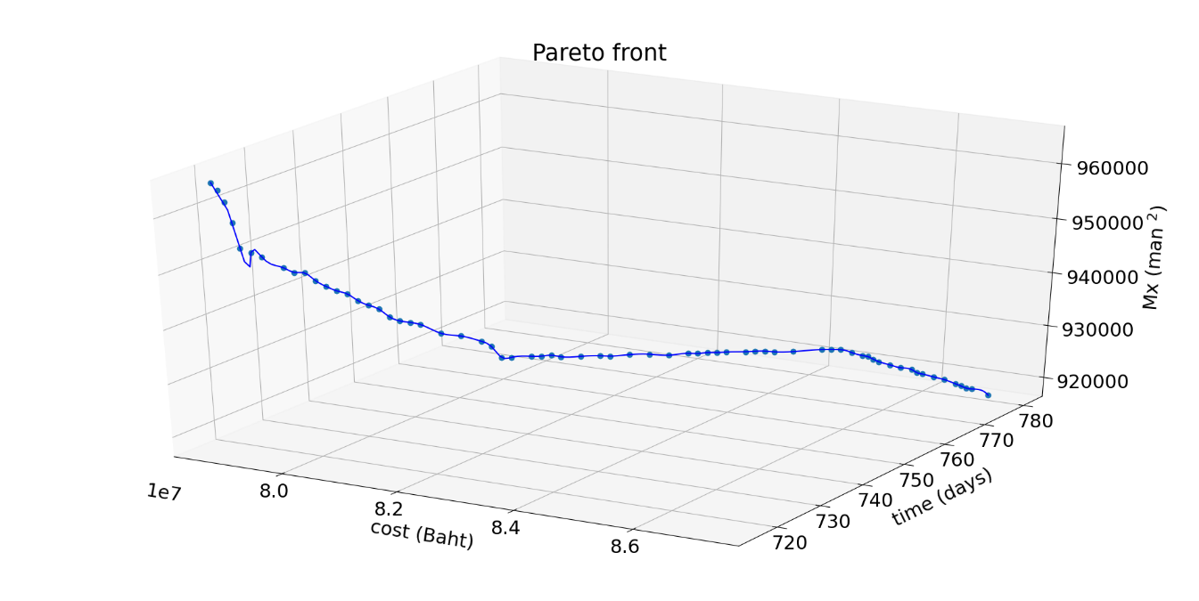

**Figure 8.** Pareto front solutions for 500 generations in 3 objectives

**Figure 9.** Pareto front solutions for 500 generations in each pair objectives

**Table 2.** Pareto Front Results

|  |  |  |  |  |  |  |  |
| --- | --- | --- | --- | --- | --- | --- | --- |
| Solution No. | Cost | Time | Mx | Solution No. | Cost | Time | Mx |
| 1 | 78701296 | 716 | 965714 | 36 | 82230313 | 756 | 925806 |
| 2 | 78718612 | 717 | 964056 | 37 | 82422522 | 758 | 925672 |
| 3 | 78735928 | 718 | 961692 | 38 | 82614730 | 760 | 925346 |
| 4 | 78753245 | 719 | 957788 | 39 | 82806939 | 762 | 924718 |
| 5 | 78770561 | 720 | 952956 | 40 | 82999147 | 764 | 924690 |
| 6 | 78866665 | 721 | 951930 | 41 | 83095252 | 765 | 924434 |
| 7 | 78962770 | 722 | 951030 | 42 | 83191356 | 766 | 924418 |
| 8 | 79154978 | 724 | 948698 | 43 | 83287460 | 767 | 924216 |
| 9 | 79251082 | 725 | 947646 | 44 | 83383564 | 768 | 924112 |
| 10 | 79347187 | 726 | 947372 | 45 | 83575773 | 770 | 923754 |
| 11 | 79443291 | 727 | 945760 | 46 | 83671877 | 771 | 923644 |
| 12 | 79539395 | 728 | 944508 | 47 | 83767981 | 772 | 923458 |
| 13 | 79635499 | 729 | 943500 | 48 | 83864085 | 773 | 923114 |
| 14 | 79731603 | 730 | 942752 | 49 | 84056294 | 775 | 922744 |
| 15 | 79827708 | 731 | 941304 | 50 | 84344607 | 778 | 922526 |
| 16 | 79923812 | 732 | 940276 | 51 | 84440711 | 779 | 922330 |
| 17 | 80019916 | 733 | 939348 | 52 | 84536815 | 780 | 922084 |
| 18 | 80116020 | 734 | 937714 | 53 | 84729024 | 780 | 921826 |
| 19 | 80212125 | 735 | 936752 | 54 | 84921232 | 780 | 921552 |
| 20 | 80308229 | 736 | 936274 | 55 | 85017336 | 780 | 921494 |
| 21 | 80404333 | 737 | 935688 | 56 | 85113440 | 780 | 921134 |
| 22 | 80596542 | 739 | 933630 | 57 | 85209545 | 780 | 920800 |
| 23 | 80788750 | 741 | 932710 | 58 | 85401753 | 780 | 920500 |
| 24 | 80980958 | 743 | 931312 | 59 | 85593962 | 780 | 920228 |
| 25 | 81077063 | 744 | 930128 | 60 | 85786170 | 780 | 920194 |
| 26 | 81173167 | 745 | 927824 | 61 | 85882274 | 780 | 919716 |
| 27 | 81269271 | 746 | 927640 | 62 | 85978379 | 780 | 919604 |
| 28 | 81461480 | 748 | 927430 | 63 | 86170587 | 780 | 919362 |
| 29 | 81557584 | 749 | 927246 | 64 | 86362795 | 780 | 919130 |
| 30 | 81653688 | 750 | 927210 | 65 | 86555004 | 780 | 918650 |
| 31 | 81653688 | 750 | 927210 | 66 | 86651108 | 780 | 918378 |
| 32 | 81653688 | 750 | 927210 | 67 | 86651108 | 780 | 918378 |
| 33 | 81749792 | 751 | 926716 | 68 | 86747212 | 780 | 918094 |
| 34 | 81942001 | 753 | 926384 | 69 | 86843317 | 780 | 918084 |
| 35 | 82134209 | 755 | 926072 | 70 | 87131629 | 780 | 917338 |

อธิบายResultsในส่วนMOGA

1.MOGAหาPareto frontได้ รูปที่8-10

2.MOGAยิ่งจำนวนGenerationsมากขึ้น จะทำให้ได้ผลลัพธ์ดีขึ้น

แสดงผลสรุปตามกราฟในรูปนี้ รูปที่11

**Figure 11.** xxx

4.2. Result Comparison (แนบpaper conference)

|  |  |  |  |
| --- | --- | --- | --- |
|  | Same Mx score at | # Pareto front | Runtime |
| LP Solver | 10,000 generation | 1 solution | 8 hours |
| NSGA-II | 282 generation | 70 solutions | 4 days |

In the actual construction time objective (Ta) equals 720 days, this proposed model wins our previous paper[ref] at 282nd generation. In previous our paper, we applied the linear programming solver to find an optimal point. It takes 10,000 generations.

5. Discussion

It can be seen the possibility of application of BIM-MOGA in complex construction projects. It provides optimization data for a project manager to decide based on existing data underneath the project along project lifecycle. MOGA Discussion. BIM MOGA Discussion

6. Conclusions

This paper provides a systematic BIM-based multi-objective genetic algorithm approach for planning and scheduling construction renovation project. It was simulated on a governmental project of an extra-large building renovation during 2018-2020. Project direct costs, indirect costs, actual scheduling, and resource usages were tracked and retrieved by the researchers. After the information was modeled as a BIM-based MOGA, <SHOWING SOME EXCITING STUFF HERE> It was creating opportunities for construction experts to develop more robust and efficient tools for construction planning and scheduling using a combination of existing BIM along with MOGA into professional practice. The construction process will be beneficial from useful information for better decision-making depending on their strategies based on the pareto front data provided.

Conclusion

1.MOGAหาPareto frontได้ รูปที่8-10

2.MOGAยิ่งจำนวนGenerationsมากขึ้น จะทำให้ได้ผลลัพธ์ดีขึ้น แสดงผลสรุปตามกราฟในรูปนี้ 11

3. MOGA ใช้ร่วมกับBIMได้

**Author Contributions:** Conceptualization, P.N., M.K. and P.C.; methodology, P.N., M.K. and P.C.; validation, P.N., S.N. and W.B.; formal analysis, S.N and W.B.; investigation, M.K. and P.N.; data curation, P.N.; writing—original draft preparation, P.N. and S.N.; writing—review and editing, M.K., P.C., K.P.; visualization, P.N. and S.N.; supervision, M.K. All authors have read and agreed to the published version of the manuscript.

**Funding:** This research received no external funding.

**Acknowledgments:** The authors would like to thank Chiang Mai University Library and Optimization Theory and Applications for Engineering SYStems Research Group (OASYS), Chiang Mai University for supporting.

**Conflicts of Interest:** The authors declare no conflict of interest.

References

1. Czmoch, I.; Pękala, A. Traditional design versus BIM based design. In *Procedia Engineering*; Elsevier Ltd, 2014; Vol. 91, pp. 210–215.

2. Mitropoulos, P.; Howell, G. A. Renovation projects: Design process problems and improvement mechanisms. *J. Manag. Eng.* **2002**, *18*, 179–185.

3. Luo, L.; He, Q.; Jaselskis, E.; Xie, J. Construction Project Complexity: Research Trends and Implications. *J. Constr. Eng. Manag.* **2017**, *143*, 4017019.

4. Saad, M.; Baba, S.; Amoudi, O. A suggested solution to improve the traditional construction planning approach. *Jordan J. Civ. Eng.* **2015**, *9*, 185–196.

5. Pūlmanis, E. Public Sector Project Management Efficiency Problems, Case of Latvia. *Reg. Form. Dev. Stud.* **2014**, *11*.

6. Chen, L.; Luo, H. A BIM-based construction quality management model and its applications. *Autom. Constr.* **2014**, *46*, 64–73.

7. Carbonari, G.; Stravoravdis, S.; Gausden, C. Building information model implementation for existing buildings for facilities management: a framework and two case studies. *Build. Inf. Model. Des. Constr. Oper.* **2015**, *1*, 395–406.

8. Khaddaj, M.; Srour, I. Using BIM to Retrofit Existing Buildings. *Procedia Eng.* **2016**, *145*, 1526–1533.

9. Volk, R.; Stengel, J.; Schultmann, F. Building Information Modeling (BIM) for existing buildings - Literature review and future needs. *Autom. Constr.* **2014**, *38*, 109–127.

10. Mill, T.; Alt, A.; Liias, R. Combined 3D building surveying techniques-Terrestrial laser scanning (TLS) and total station surveying for BIM data management purposes. *J. Civ. Eng. Manag.* **2013**, *19*, 23–32.

11. Barazzetti, L.; Banfi, F.; Brumana, R.; Gusmeroli, G.; Previtali, M.; Schiantarelli, G. Cloud-to-BIM-to-FEM: Structural simulation with accurate historic BIM from laser scans. *Simul. Model. Pract. Theory* **2015**, *57*, 71–87.

12. Ipsilandis, P. G. Multiobjective Linear Programming Model for Scheduling Linear Repetitive Projects. *J. Constr. Eng. Manag.* **2007**, *133*, 417–424.

13. Zhang, H.; Li, X.; Li, H.; Huang, F. Particle swarm optimization-based schemes for resource-constrained project scheduling. *Autom. Constr.* **2005**, *14*, 393–404.

14. Zhang, H. Ant Colony Optimization for Multimode Resource-Constrained Project Scheduling. *J. Manag. Eng.* **2012**, *28*, 150–159.

15. Hegazy, T. Optimization of resource allocation and leveling using genetic algorithms. *J. Constr. Eng. Manag.* **1999**, *125*, 167–175.

16. Chan, W. T.; Hu, H. Precast production scheduling with Genetic Algorithms. In *Proceedings of the IEEE Conference on Evolutionary Computation, ICEC*; 2000; Vol. 2, pp. 1087–1094.

17. El-Rayes, K.; Jun, D. H. Optimizing resource leveling in construction projects. *J. Constr. Eng. Manag.* **2009**, *135*, 1172–1180.

18. Murata, T.; Ishibuchi, H. MOGA: multi-objective genetic algorithms. In *Proceedings of the IEEE Conference on Evolutionary Computation*; IEEE, 1995; Vol. 1, pp. 289–294.

19. Eshtehardian, E.; Afshar, A.; Abbasnia, R. Fuzzy-based MOGA approach to stochastic time–cost trade-off problem. *Autom. Constr.* **2009**, *18*, 692–701.

20. Peng, B.; Flager, F. L.; Wu, J. A method to optimize mobile crane and crew interactions to minimize construction cost and time. *Autom. Constr.* **2018**, *95*, 10–19.

21. Zhao, S.; Li, Z. Multi-objective optimization for construction site layout planning problem under fuzzy random environment. In *Proceedings - 2014 7th International Joint Conference on Computational Sciences and Optimization, CSO 2014*; Institute of Electrical and Electronics Engineers Inc., 2014; pp. 641–645.

22. Monghasemi, S.; Nikoo, M. R.; Khaksar Fasaee, M. A.; Adamowski, J. A novel multi criteria decision making model for optimizing time-cost-quality trade-off problems in construction projects. *Expert Syst. Appl.* **2015**, *42*, 3089–3104.

23. Faghihi, V.; Reinschmidt, K. F.; Kang, J. H. Construction scheduling using Genetic Algorithm based on Building Information Model. *Expert Syst. Appl.* **2014**, *41*, 7565–7578.

24. Moon, H.; Kim, H.; Kamat, V. R.; Kang, L. BIM-Based Construction Scheduling Method Using Optimization Theory for Reducing Activity Overlaps. *J. Comput. Civ. Eng.* **2015**, *29*, 04014048.

25. Gbadamosi, A. Q.; Mahamadu, A. M.; Oyedele, L. O.; Akinade, O. O.; Manu, P.; Mahdjoubi, L.; Aigbavboa, C. Offsite construction: Developing a BIM-Based optimizer for assembly. *J. Clean. Prod.* **2019**, *215*, 1180–1190.

26. Asl, M. R.; Bergin, M.; Menter, A.; Yan, W. BIM-based Parametric Building Energy Performance Multi-Objective Optimization. In *Conference: Proceedings of the Conference of Education and Research in Computer Aided Architectural Design in Europe (eCAADe)*; 2014.

27. Zanchetta, C.; Cecchini, C.; Bellotto, C. BIM-Based multi-objective optimization process for energy and comfort simulation: existing tools analysis and workflow proposal on a case study.

28. Salama, T.; Moselhi, O. Multi-objective optimization for repetitive scheduling under uncertainty. *Eng. Constr. Archit. Manag.* **2019**, *26*, 1294–1320.

29. Agrama, F. A. Multi-objective genetic optimization for scheduling a multi-storey building. *Autom. Constr.* **2014**, *44*, 119–128.

30. Rao, S. S. *Engineering Optimization: Theory and Practice: Fourth Edition*; 2009.

31. Palisada Corporation *Evolver User’s Guide : The Genetic Algorithm Solver for Microsoft Excel, Version 7*; Palisade Corporation: Ithaca, NY USA 14850, 2015.

32. Ghoddousi, P.; Eshtehardian, E.; Jooybanpour, S.; Javanmardi, A. Multi-mode resource-constrained discrete time-cost-resource optimization in project scheduling using non-dominated sorting genetic algorithm. *Autom. Constr.* **2013**, *30*, 216–227.

**Publisher’s Note:** MDPI stays neutral with regard to jurisdictional claims in published maps and institutional affiliations.

|  |  |
| --- | --- |
|  | © 2020 by the authors. Submitted for possible open access publication under the terms and conditions of the Creative Commons Attribution (CC BY) license (http://creativecommons.org/licenses/by/4.0/). |